Technical Design Document

Documentum Service

Contents

1.0. Objective 3

1.1. Naming Conventions 3

1.2. Tools and Technologies 3

1.3. Pre-Requisite 3

2.0. Architecture Diagram 4

2.1.1 Vitrana documentum service functional description: 5

2.1.2 Configuration 5

3.0. References 6

4.0. Revision History 6

1. Objective

The objective of the document is to explain the technical design of **DocumentumDFCService** service. The document explains the technical architecture, service functional specification and its configuration.

* 1. **Naming Conventions**
* Use Pascal Case for Class Names, Method Names and Namespaces.
* Use camel Case for variables defined inside a method.
* Do not use names that begin with numeric character.
* Use meaningful and specific names.
* Avoid naming conflicts with existing .NET Framework namespaces, or types.
* All interface names should begin with an “I”.
  1. **Tools and Technologies**
* Visual Studio 2013.
* Language C#
* The logging functionality has been built on top of Log4Net library.
  1. **Pre**-**Requisite**
* Documentum server 7.1 should be up and running.
* DocBrocker should be up and running on documentum server.
* DFC Client 6.7 or 7.1
* Windows server 2008R2 or above.
* .Net framework 4.5.
* Oracle client 11.2.0.3.0
* ODAC 11.2.0.3.0 32bit.
* A System user who have admin access on application server.
* When we install DFC Client 6.7 on application server it should be able to connect DocBrocker.

1. Architecture Diagram

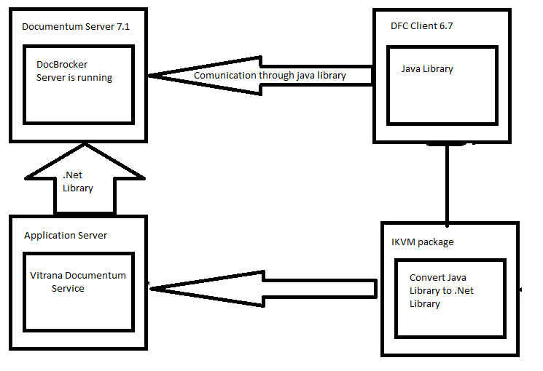

Figure 1 Documentum DFC Service and server communication architecture diagram

1. Service Method description

|  |  |  |
| --- | --- | --- |
| Method Name | IN Parameters / OUT Parameters | Description |
| ProcessDocument | **IN Parameters:** N/A **OUT Parameter:** N/A | This method is used to get the raw data from database create the document on local drive and upload in documentum after that update the status in database with documentum doc_id |
| WriteDocument | **IN Parameters:** documentFullPath(local drive) **OUT Parameter:** bool | This method is used to write the document on local drive folder |
| UploadDoc | **IN Parameters:** docInputFolderPath **OUT Parameter:** List of DocumentumEntity class | This method is used to actully upload the document in documentum |

1. DocumentumEntity class description

|  |  |  |
| --- | --- | --- |
| Property Name | **Data Type** | Description |
| DocumentName | String | This uploaded document name in documentum |
| IdfID | String | The successfully uploaded document docId |
| IdfPath | String | The uploaded document path in documentum |
| Status | Integer | 1 or success 0(zero) for fail |
| ExceptionMessage | String | If any exception occurred during the upload document in documentum than it will return exception message otherwise null |

* + 1. **documentum service functional description:**

This service is used to get the r2 or r3 attachment file data in raw format and write that content as file in local drive folder after that it will upload that document in documentum through DFC Client 6.7 class library after that it will update the status with documentum docId in database and write the success message in log file with the details of filename (attachment name), importId, documentum docId. If attachment failed to upload in documentum it will log exception message in log file.

* + 1. **Configuration**

|  |  |  |
| --- | --- | --- |
| Parameter Name | Value | Description |
| DBConnString | data source, password, user id  set these three parameter value according to your database | This parameter is used to connect to database. |
| ConfigFilePath | Window service base directory ConfigFiles folder path | This parameter is used to read the service is enabled or not value. |
| DocumentumURL | Documentum server web access url | This parameter is used to access the documentum application |
| DocumentumServer | Documentum server id address | This parameter is used to connect the documentum server through dfc |
| DocumentumConfigFolderPath | DFC Client 6.7 properties file path | This parameter is used to read the properties file for make the connection with server |
| UserName | Documentum server user name who can login on in documentum web application and attach the document | The UserName |
| Password | Password of documentum comunicator user | The Password |
| CabinetName | Documentum CabinetName | Cabinet is parent container of folder, document et.c |
| RepositoryName | Documentum RepositoryName | The repository name |
| FolderName | Documentum FolderName | FolderName is which the service will attach the document |
| Loggerconfigfile | Window service base directory ConfigFiles folder path | This parameter is used to read the logger config file |

1. References

There were no references identified for this document

1. Revision History

|  |  |  |  |
| --- | --- | --- | --- |
| **Version No.** | **Date (DD/MM/YYYY)** | **Description / Reason for Change(s)** | **Author(s)** |
| 1.0 | 13-Jul-2017 | New Document Created | Ashok Kolwal |
|  |  |  |  |